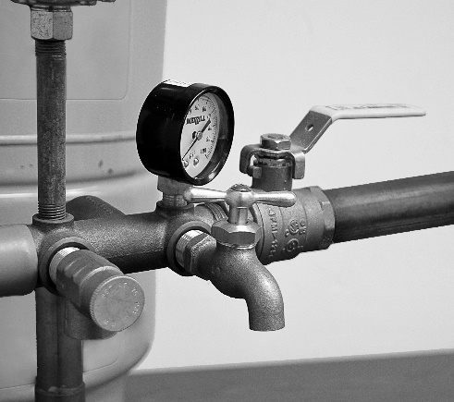
How to Take a Water Sample
Water samples must be returned to the lab within 30 hours of the time they were collected. Clean Water Testing is open Monday through Friday 8AM-5PM, please plan accordingly for weekends and holidays (there is an after-hours refrigerator for sample dropoff).

1. Wash hands thoroughly with soap and water.
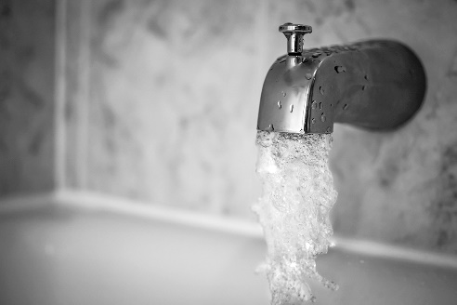
2. Decide where you would like to collect the water sample from. The sample faucet located next to the pressure tank can be a good option.
3. Turn on your bathtub’s cold water and allow it to run during the entire sampling process (approximately 10 minutes).
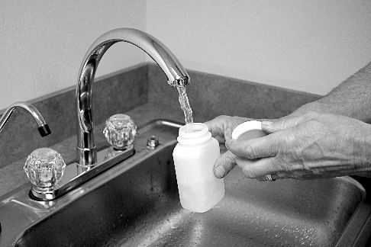
4. Remove any faucet screens, attachments, or hoses from the sample source and flush the fixture for approximately five minutes. Then slow the water flow to minimize splashing.
5. Remove the cover from the sample bottle, being careful not to touch
6. Fill the clear sample bottle to the fill line marked on the bottle (or above the fill line) or 1” from the top if the bottle does not have a fill line (Red capped bottles and small white capped bottles). Do not rinse or overfill the bottle. Replace cap securely. If your kit contains multiple bottles, repeat this step until all bottles have been filled from the same location. Turn off all running water. Follow enclosed directions for all specialty bottles/kits.
7. Complete the front of this form as fully as possible and place in the return packaging with the sample bottle(s). Your water sample will not be analyzed if the front of this form is not filled out.
8. Return the package to our office or select a next-day shipping service to return the sample to Clean Water Testing. Please return samples to the lab within 30 hours from the time that you collect the sample!

If testing for volatile organics, please refer to the sampling instructions with the VOC test vials or find them on our website at the address below. If a “first draw” sample is needed for lead or copper tests, please see our collection procedures on our website at the address below. For specialty testing, pleae contact the lab for vials and directions.
www.CleanWaterTesting.com/Resources/Collect-A-Water-Sample


(800) 801-7590 | (920) 733-7590
1990 Prospect Court
Appleton, WI 54914
www.cleanwatertesting.com

